Step 1: Find out the target machine IP (192.168.56.103)
Step 2: Scan with nmap to find out the open ports and services
Step 3: Here we found that this machine has a http service open on port 80, So we browse it on a web browser.

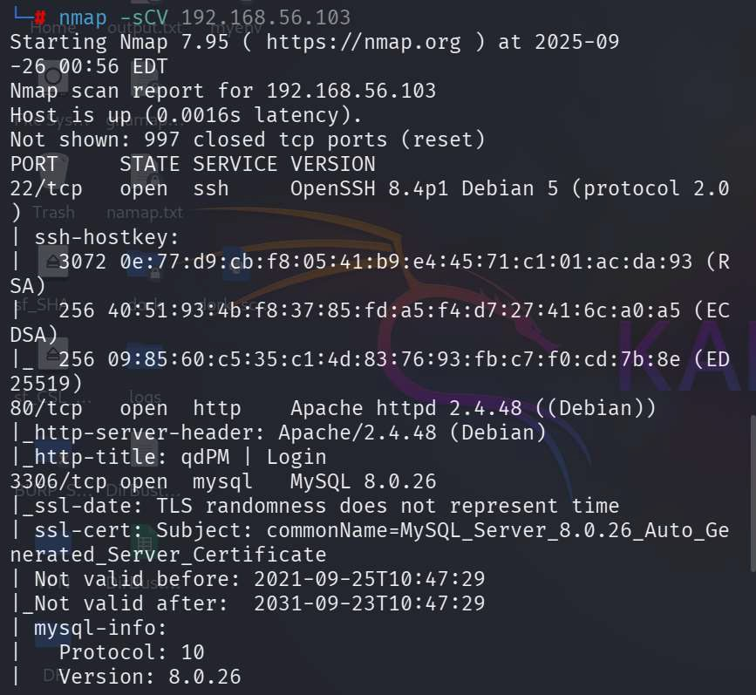

Step 4: A CMS is running on this machine named ‘qdPM’ and the version is 9.2
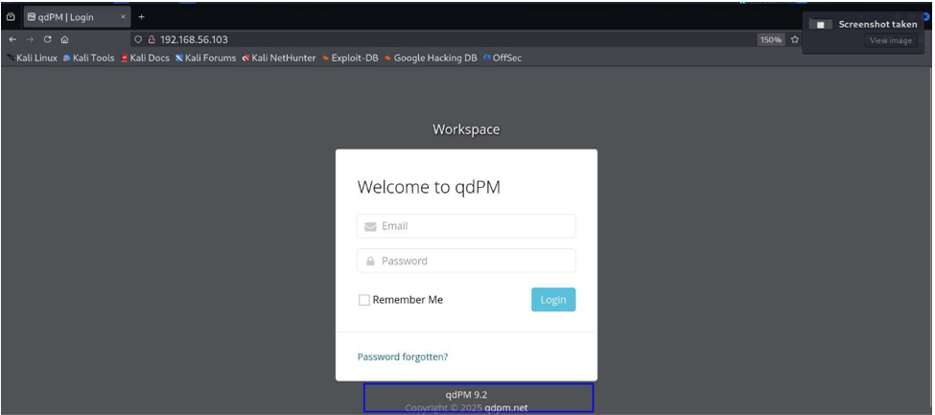
Step 5: Now find out is there any available vulnerability/exploit for this qdPM 9.2 version or not . We found one on exploitDB named password exposure.
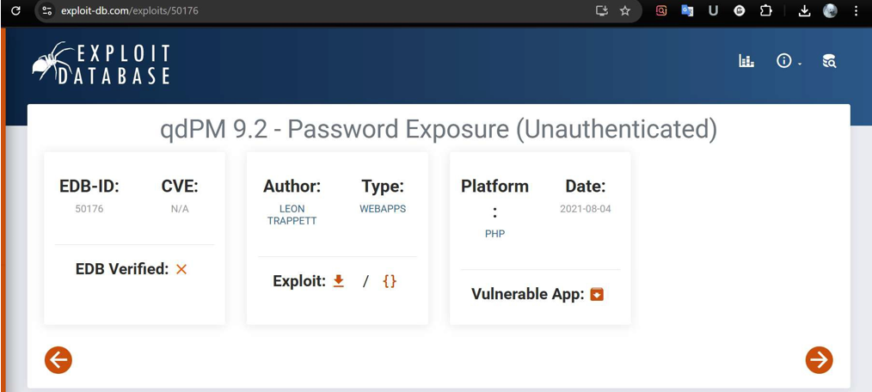

Step 6: Now Download that exploit and open it. Here we found that an .ylm file store password and connection string and share the location of that file.
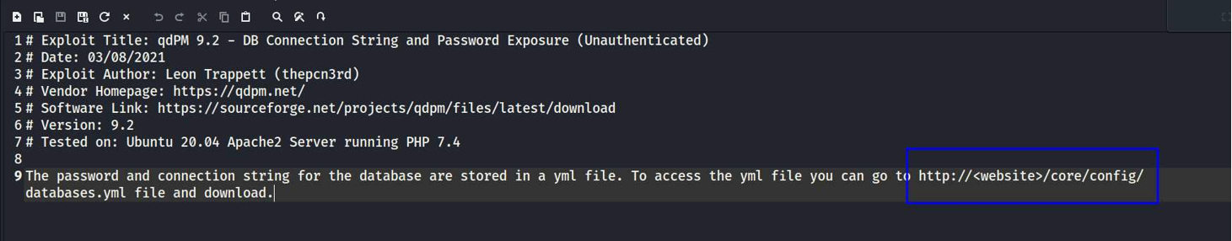

Step 7: We visited that location on the web browser and found that yml file. Here we found a username and password for the database.
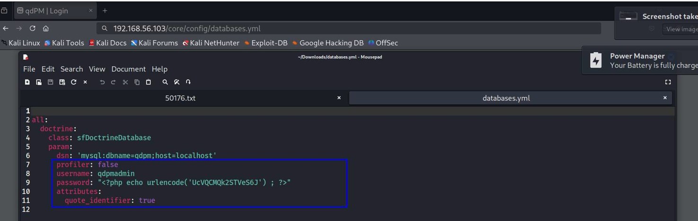

Step 8: Try to login with the user credentials in mysql database. Getting an error of SSL certificates.

Step 9: So try again with ssl skip command. And now can log into the database.
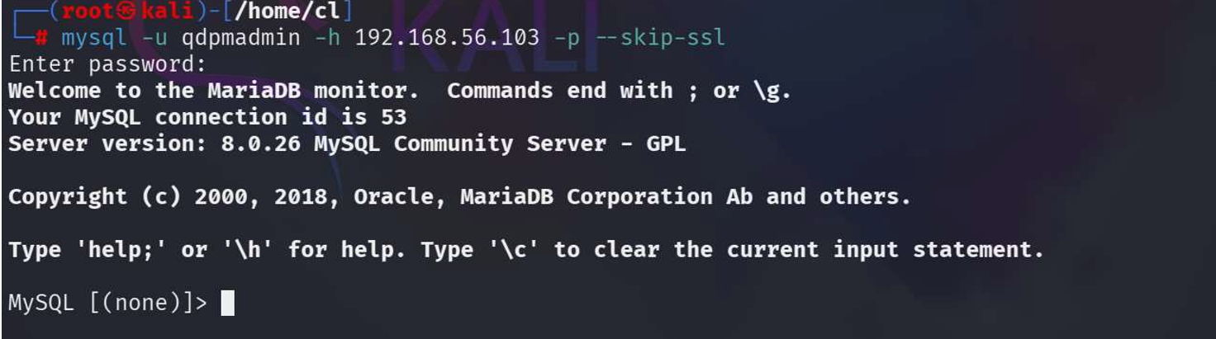

Step 10: Show all databases here and use the staff database.
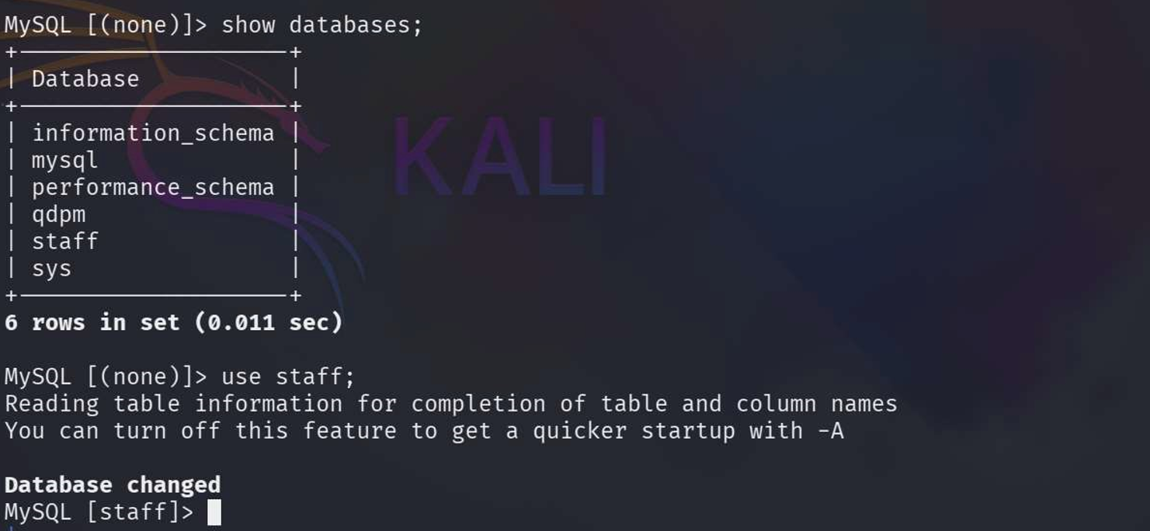

Step 11: show all tables of the staff database and here we found some useful tables.(login & user)
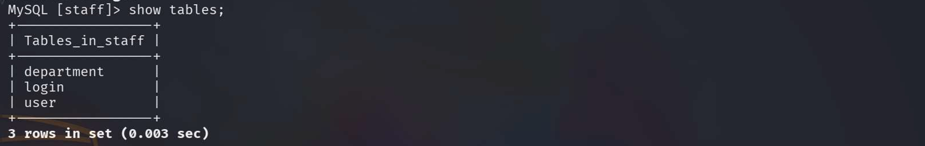
Step 12: Show all content of those 2 tables and found some users and passwords.
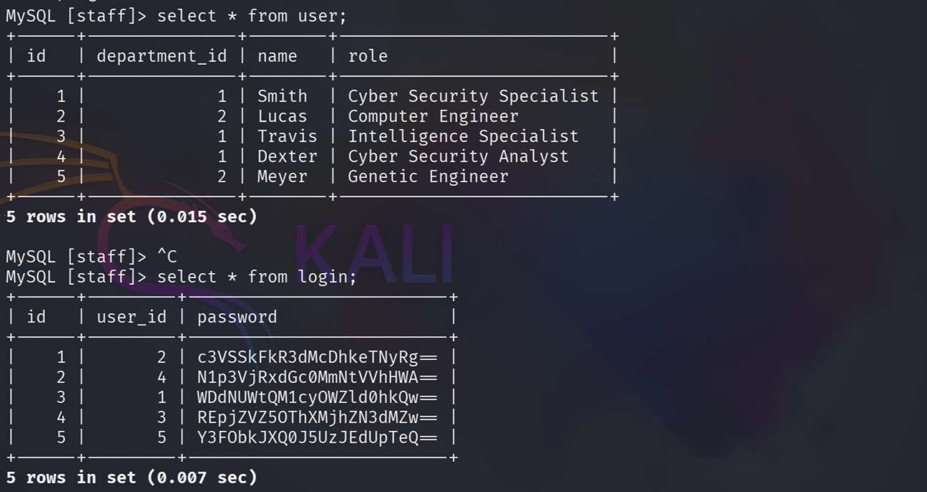

Step 13: Looks like the passwords are stored in ‘base64’ format in the database so we are using here cyberchef for converting base64 to normal from.
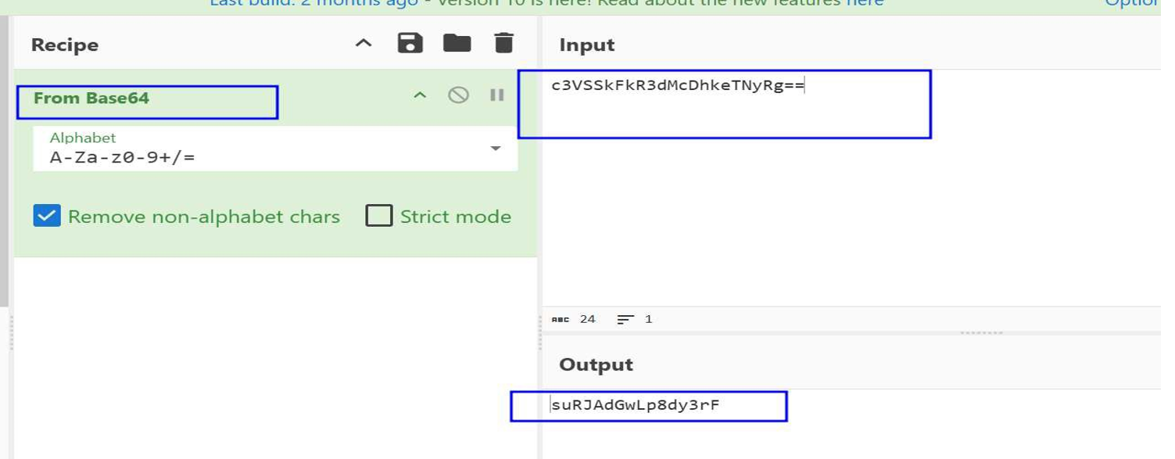

Step 14: WE saved all users and converted password into separate files named user.txt & pass.txt and try to brut force it by hydra with ssh service.
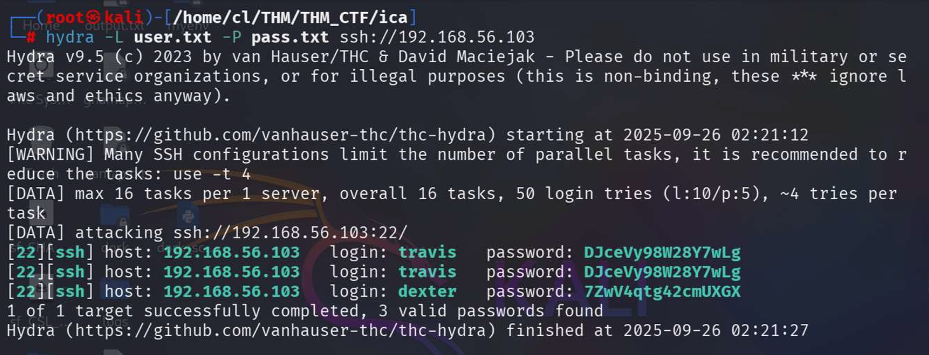

Step 15: We found 2 users with their password and try to login it from my local machine with SSH.
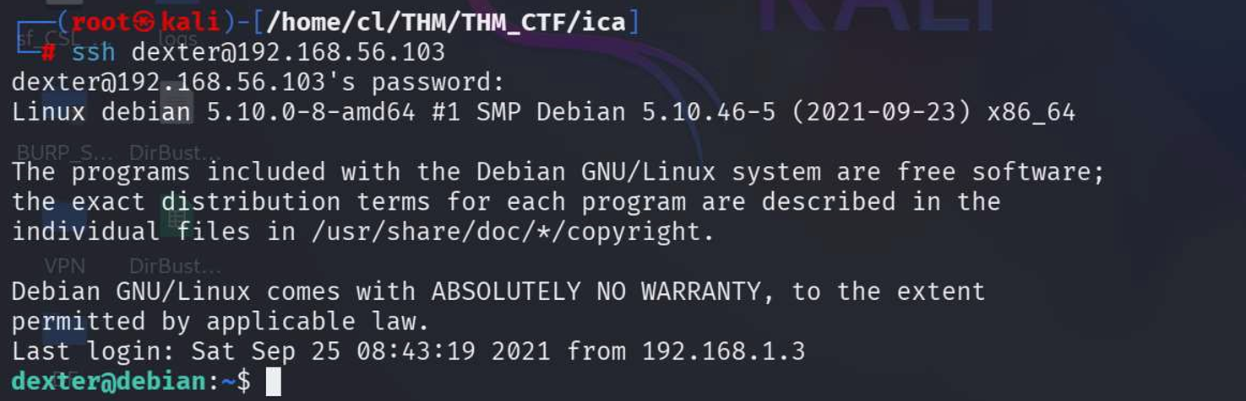

Step 16: Now this user is not a sudo user so need to privileged escalation for full access. With this command [find / -perm -4000 -type f -exec ls -la {} 2>/dev/null \;] we find out on which directory/file this user have acess with which permission. Get a file named /opt/get_access
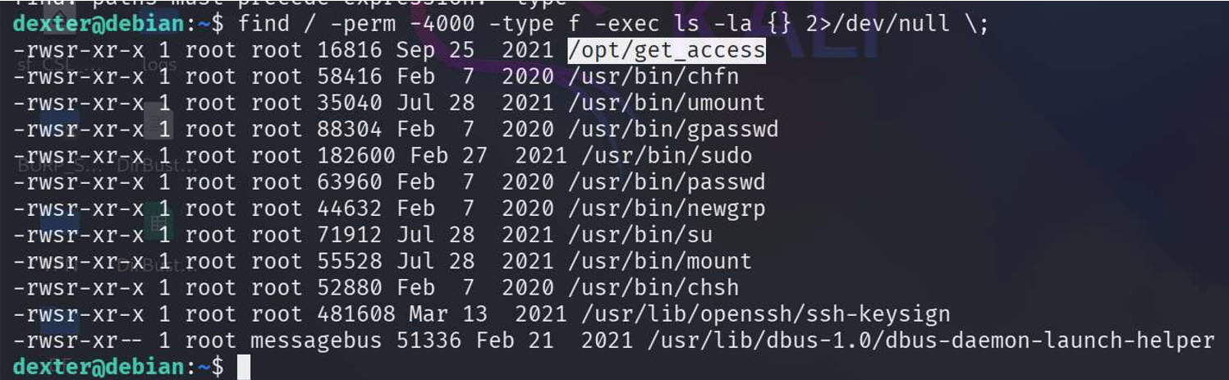

Step 17: Use command for privileged exclusion.
echo $PATH
echo '/bin/bash' >> /tmp/cat
export PATH=/tmp:$PATH
echo $PATH
chmod +x /tmp/cat
